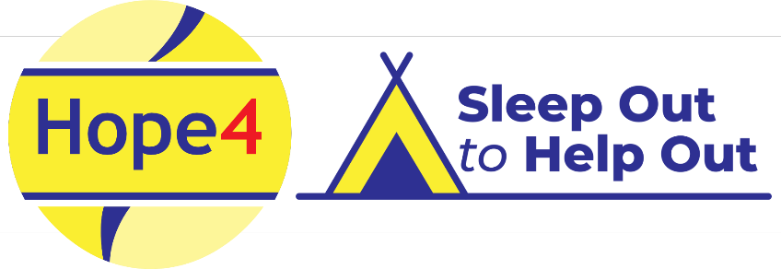

Sleep Out to Help Out 2024
Terms and conditions:
- By registering for this event, you are agreeing that you, and anyone you are registering to attend with you, understand the nature of the event and will take part in accordance with these terms and conditions.

- Every person taking part in this event will be asked to read, agree, and then sign to record your agreement. Failure to do this will result in you not being allowed to participate.

- Minimum age for participation in this event is 11 years old. If a person under the age of 18 is taking part then a responsible adult (someone 18 or over) must register for them and take full responsibility for this person for the duration of the event. Groups that have under 18 year olds must observe the minimum requirements for this event which is 1 adult to 3 under 18s.

- All individuals taking part are responsible for ensuring they are medically and physically able to undergo this activity.

- Participants take part at their own risk and the organisers cannot be held responsible for any loss or damage to personal affects, for personal accidents or for injury or loss to third parties, other than because of Hope4 (Rugby Ltd’s negligence.

- Alcohol and drugs, deliberate distruption to other people’s dwellings, use of onscene language, unruly or anti-social behaviour will not be tolerated. Singing, loud music or loud talking must stop by midnight. The organisers reserve the right to stop you from entering the event and/or to ask you to leave the event at any time, regardless of the time. If this happens it will be the responsibility of the participant to inform any sponsors of their actions.

